# Appendix A

## Kaiser window comparison for varying alpha.

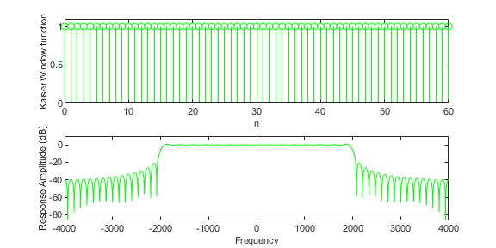

Figure 1: Alpha = 0

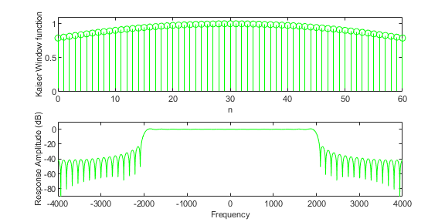

Figure 2: Alpha = 1

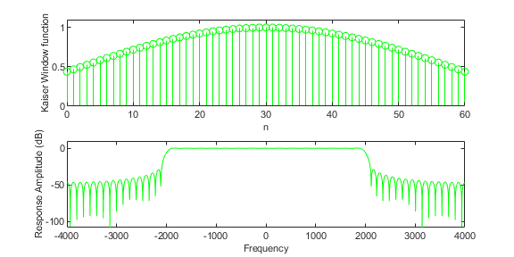

Figure 3: Alpha = 2

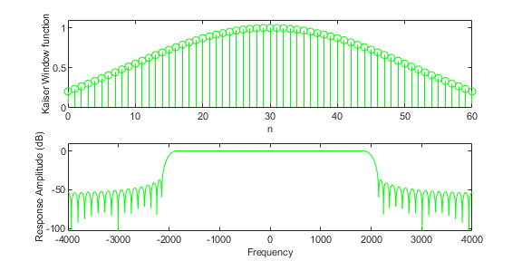

Figure 4: Alpha = 3

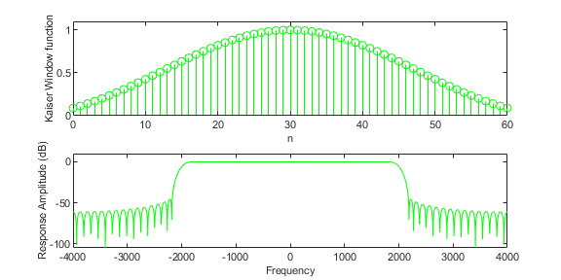

Figure 5: Alpha = 4

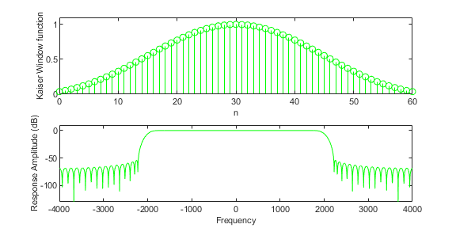

Figure 6: Alpha = 5

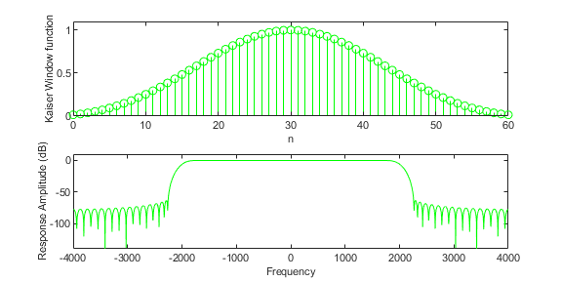

Figure 7: Alpha = 6

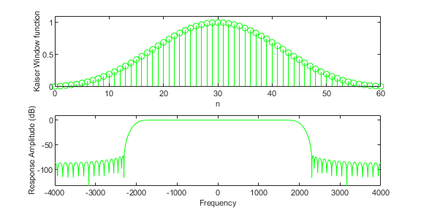

Figure 8: Alpha = 7

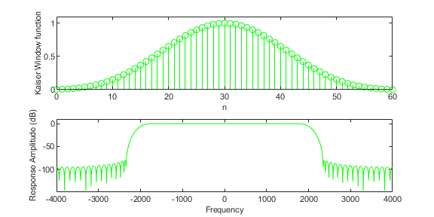

Figure 9: Alpha = 8

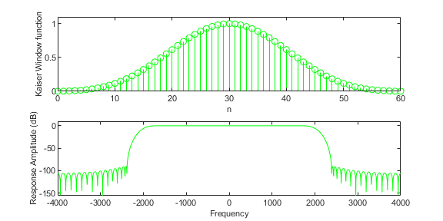

Figure 10: Alpha = 9

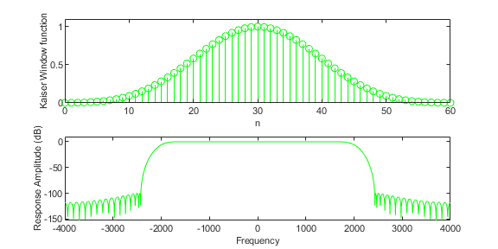

Figure 11: Alpha = 10

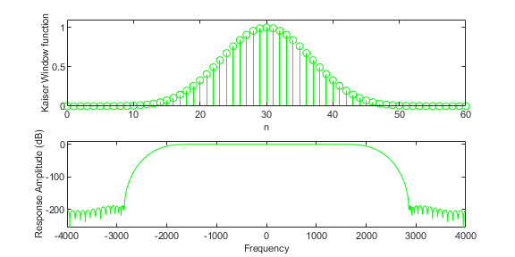

Figure 12: Alpha = 20

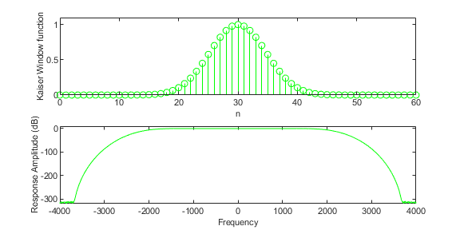

Figure 13: Alpha = 40

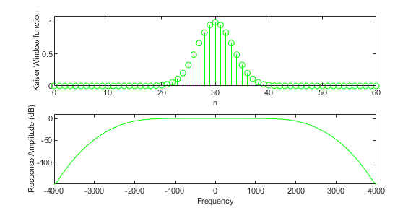

Figure 14: Alpha = 80